

### **TITLE: LabVIEW AND myDAQ BASES CONTACTLESS WATERLEVEL CONTROLLER**

**DEPARTMENT OF ELECTRONICS & COMMUNICATION ENGINEERING**

**TECHNODIUM 2K23**

**Date: 19-04-2023**

**A MINI PROJECT REPORT**

***Submitted by***

|  |  |
| --- | --- |
| **JASWANTH J** | **(113320106018)** |
| **RAVI TEJA M** | **(113320106022)** |
| **SANTHOSH D** | **(113320106037)** |

**1 Project Guide Signature**

**ABSTRACT:**

Shortage in water supply is one of the major issues that some major cities throughout the world are facing nowadays. Due to not having a full day water supply, households will have to efficiently manage the problem of water shortage and overcome the crises. This paper presents a system that indicates and controls the level of water in overhead tanks. Water level sensors or IR sensors are employed to detect the level of the water between predefined minimum and maximum levels. LabVIEW, which is a graphical programming language that uses a dataflow model is used to program microcontroller board MYDAQ that is an interface between the software and the rest of the circuit components. From measured results good performance and accurate results are achieved.

Keywords: LabVIEW, microcontroller, absolute error.

**2**

**INTRODUCTION:**

Dwindling water supplies will affect city citizens and exacerbate conflict in the cities throughout the world. Due to not having full day water supply and besides public response to water conservation regulations, households need to think of effective solutions like installing water reservoir tanks down the floor and overhead tanks to efficiently manage the problem of water shortage and overcome the crises. In this regard, water pumps are being used to pump up water from the down water tank to the overhead tank. The main purpose of this research is to use LabVIEW to control MYDAQ board to automate the water level in an overhead tank and indicate the level of the water. IR sensors are used as an alternative to conductors as a sensor based on distance measurement of the water surface from the predefined minimum and maximum levels and more importantly the water level is continuously detected. The low cases of water make motor on to fill the water to the level.

**3**

**NEED FOR THE PROJECT:**

* **We can ensure that the use of this project widely experiences the Save water theme and we can initialize this method in many sources.**
* **Water conservation: By controlling the water level in a tank or reservoir, you can ensure that water is not wasted through overflow or leaks.**
* **Irrigation: In agricultural settings, a water level controller can be used to ensure that crops are getting the appropriate amount of water.**
* **Flood control: In areas prone to flooding, a water level controller can be used to monitor and control water levels to prevent damage to property and infrastructure.**
* **Water treatment: In water treatment plants, a water level controller can be used to ensure that water is properly processed and treated before distribution.**
* **Aquariums: A water level controller can be used in aquariums to maintain a consistent water level and prevent overflows.**
* **To build this project, you could use LabVIEW and a MyDAQ board to monitor the water level in a tank or reservoir, and then control a valve or pump to adjust the water level as needed. You could also add sensors to monitor other factors such as temperature and pH levels and use LabVIEW to create a user interface for monitoring and controlling the system.**

**4**

**BLOCK DIAGRAM:**

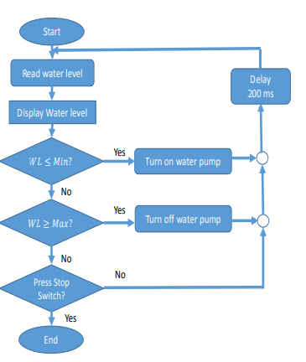

**Flow of process:**

* The overhead tank has two levels, maximum and minimum.
* Ultra-sonic sensors are used to continuously detect the level of water (WL) in the water tank.
* Via Arduino UNO, LabVIEW monitors the water level and shows the current level of the water.
* If WL Min, the relay will turn the water pump on to pump water into the water tank. And the water level will also be monitored.
* If not, the second scenario is WL ≥ Max, the Relay will be instructed to turn off the water pump.
* If none of the above conditions are achieved, the program will be continued in monitoring the water level until a predefined condition is achieved.

**5**

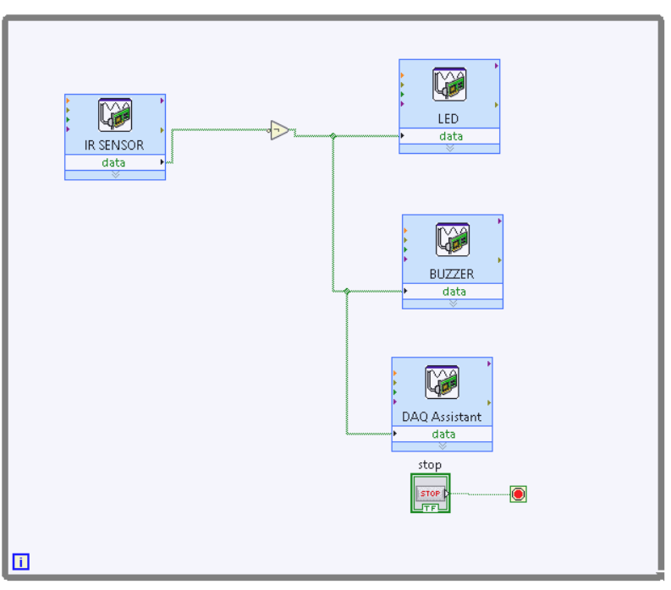

**The above picture shows that the block diagram of the DAQ and LabVIEW arrangement.**

**6**

**PROPOSED WORK:**

The proposed system is composed of down and overhead water tanks, a pump to pump up water from the down reservoir to the overhead tank. The Arduino UNO board operates based on the program written in LabVIEW. It will detect the water level via IR sensors as well as instruct the relay circuit when predefined water level limitations are reached. The whole process and control signaling are exchanged in a wired environment. To protect the water pump from working when there is no water in the down reservoir, to be cost effective extra sensors are not used in the down reservoir but the DAQ board is programed in a way if there is no increment in the water level, the relay circuit will be instructed to turn off the water pump. An automatic water level controller is developed and implemented. DAQ has been chosen to automate the process of water pumping. Water level detection in both source and overhead tanks, switch on/off the pump accordingly are the main controlling signals the circuit

**7**

**EQUIPMENT INFO:**

**SOFTWARE:**

**LabVIEW 2017:**

LabVIEW is a graphical programming language developed by National Instruments (NI) in 1986. It is commonly used for data acquisition, instrument control, and industrial automation applications.

In LabVIEW, programs are called virtual instruments (VIs) and are represented graphically as block diagrams. The block diagrams consist of nodes, which are graphical representations of functions or operations, and wires, which connect the nodes and represent the data flow between them.

**LED BULB:**

The led bulb was used as an indicator, at the project to illustrate the Detection mechanism.

**MYDAQ:**

The myDAQ device is small and portable, making it easy to use in a variety of environments. It includes a variety of analog and digital inputs and outputs, such as voltage, current, temperature, and digital I/O, and can sample data at rates up to 200 KS/s.

The myDAQ is often used in engineering, physics, and other science courses to teach fundamental concepts of data acquisition, signal processing, and control systems. It is also used by researchers and engineers for prototyping and testing of small-scale systems and for quick data acquisition tasks. 8

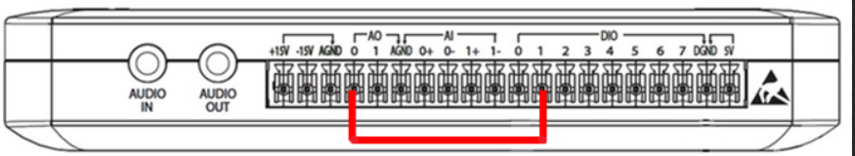

**MyDAQ pin configurations**

**Water Pump (Rio Plus Aqua Pump)**

The pump provides a versatile water pump system designed with high efficiency and reliability at lower cost. The pump used here has a capacity of 262 liters (about 69.21 gal) per hour.

**Relay Circuit**

This component is controlled by the Arduino UNO board based on the measured water level signals received back by ultrasonic sensors [8]

**9**

**COMPONENTS USED:**

* LabVIEW Software
* myDAQ
* Relay (Single Module)
* Pump
* IR sensor
* LED’s
* Connectors
* Buzzer
* Required elements.

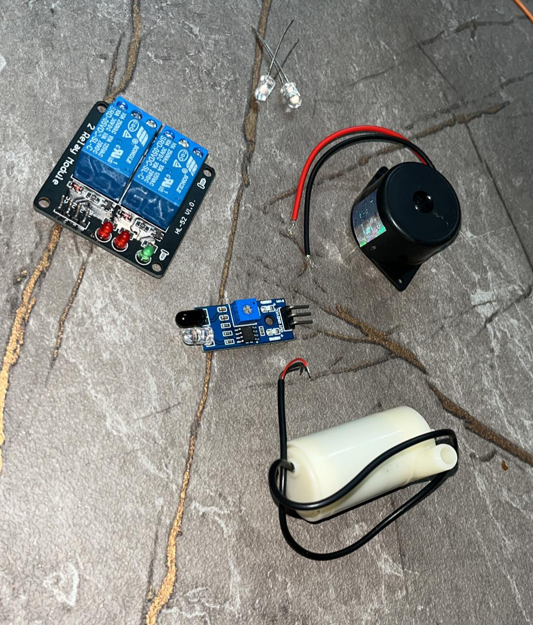

10

**APPLICATIONS:**

**Water level controllers using LabVIEW and myDAQ can have a wide range of applications in different industries and settings. Here are some examples:**

1. **Agriculture: In agriculture, water level controllers can be used to automatically control the water level in irrigation systems, ensuring that crops receive the right amount of water.**
2. **Industrial process control: Water level controllers can be used to monitor and control the level of liquids in industrial processes, such as chemical processing and manufacturing.**
3. **Water treatment: Water level controllers can be used to control the level of water in treatment systems, such as wastewater treatment plants and water filtration systems.**
4. **Aquaculture: In aquaculture, water level controllers can be used to maintain the water level in fish tanks and other aquatic systems, ensuring optimal conditions for fish and other aquatic organisms.**
5. **Flood monitoring and control: Water level controllers can be used to monitor water levels in rivers, lakes, and other bodies of water, and to trigger flood control measures if necessary.**
6. **Swimming pool maintenance: Water level controllers can be used to maintain the water level in swimming pools, ensuring that they remain clean and safe for use.**

**Overall, water level controllers using LabVIEW and myDAQ can be used in any application where precise control of water levels is important, and where automation can improve efficiency and safety.**

**11**

**REFERENCES:**

[1] E. V. Ebere and O. O. Francisca, “Microcontroller based Automatic Water level Control System,” Int. J. Innov. Res. Comput. Commun. Eng., vol. 1, no. 6, pp.

[2] S. Pudasaini, A. Pathak, S. Dhakal, and M. Paudel, “Automatic Water Level Controller with Short Messaging Service (SMS) Notification,” Int. J. Sci. Res. Publ., vol. 4, no. 9, pp. 518–521, 2014.

[3] A. A. M. Eltaieb and Z. J. Min, “Automatic Water Level Control System,” Int. J. Sci. Res., vol. 4, no. 12, pp. 1505–1509, 2015.

[4] S. M. K. Reza et al., “Microcontroller Based Automated Water Level Sensing and Controlling: Design and Implementation Issue,” World Congr. Eng. Comput. Sci. Vols 1 2, vol. I, pp. 220–224, 2010.

[5] “Ultrasonic Sensor - HC-SR04 - SEN-13959 - SparkFun Electronics.” [Online]. Available: https://www.sparkfun.com/products/13959. [Accessed: 18-Mar-2017].

[6] A. Store, “Arduino UNO Rev3,” online, 2014. [Online]. Available: https://store.arduino.cc/usa/arduino-uno-rev3. [Accessed: 22-Mar-2017].

[7] “TAAM, Aquarium Products.” [Online]. Available: http://www.riopump.net/products_pumps/Rioplus_de sc.html. [Accessed: 26-Mar-2017].

[8] “SRD-05VDC-SL-C Datasheet PDF - SRD RELAY - SONGLE.” [Online]. Available: http://www.datasheetcafe.com/srd-05vdc-sl-cdatasheet-pdf/. [Accessed: 26-Mar-2017].

[9] N. Instruments, “Образовательные , научные и инженерные приложения в среде е LabVIEW и технологии National Instruments,” 2010.

12

**CONCLUSION:**

The prototype has been programed and implemented successfully. Good accuracy is achieved in detecting the water level, and controlling system when introduced constraints are taken into consideration. Linearity in the relationship curve between desired and actual water level values achieved. Staying absolute error below 2.3mm (about 0.09 in) maximum is the marker of the system accuracy. By automating the water level control process, these systems can improve efficiency, reduce costs, and enhance safety, while also providing accurate and reliable water level control for critical applications.

Overall, water level controllers using LabVIEW and myDAQ are an excellent choice for anyone looking for a flexible, customizable, and easy-to-use solution for water level control.

**13**

**PROJECTPHOTOS:**

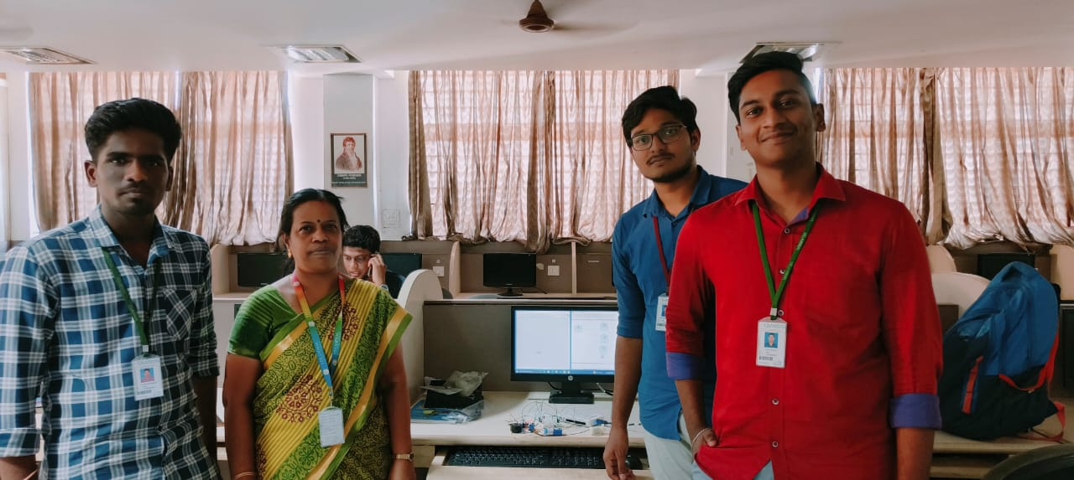

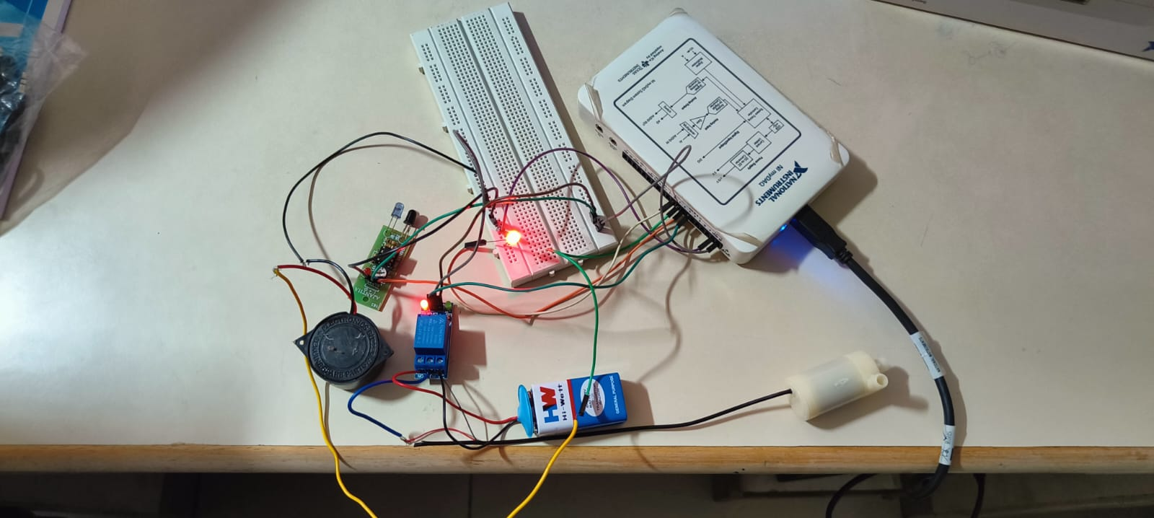

**14**

**PRESENTED BY:**

 

**RAVI TEJA M JASWANTH J SANTHOSH D**

**DEPT OF ECE-3RD**  **DEPT OF ECE-3RD**   **DEPT OF ECE-3RD**

**GUIDE:**



**KAMALAM MAM**

ASSISTANT PROFESSOR

**DEPT OF ECE**

**VELAMMAL INSTITUTE OF TECHNOLOGY**

**15**